

Megha Sharma  
16148393  
mszzf@mail.umkc.edu

CS551 Advanced Software Engineering

Midterm: Hackathon(Take-home programming)

# Design

1. System Architecture

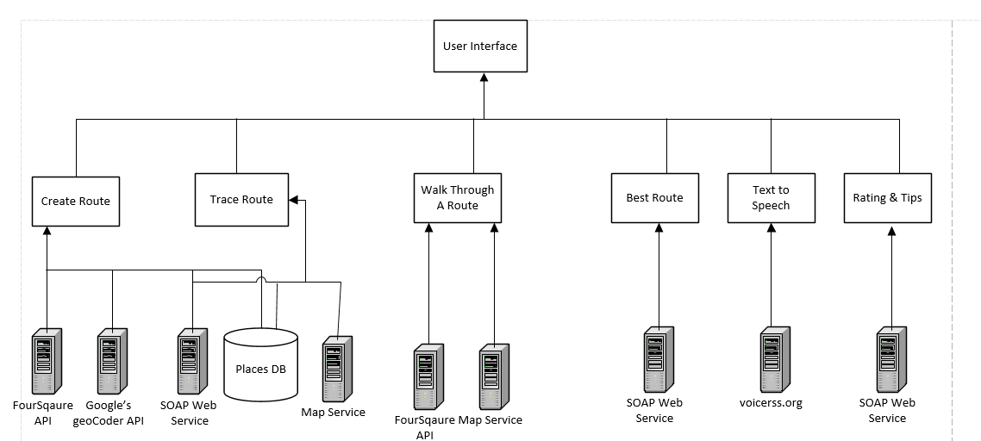

1. Class Diagram

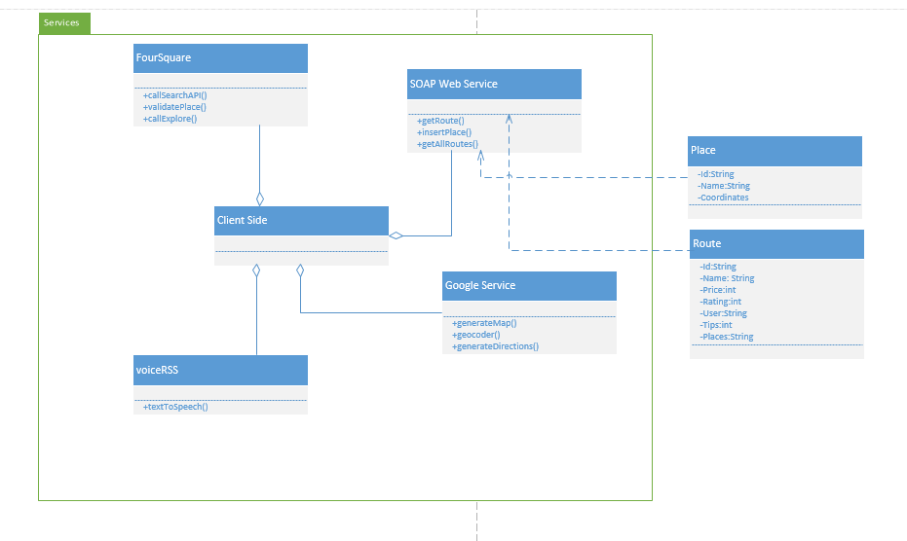

# Features implemente

1. Web Services:
   1. Own Services:
   * SOAP webservice was implemented to store the route information along with the various places visited.
   * SOAP webservice was implemented to query the database for all the routes or based on the source and destination if the user enters one
   * SOAP webservice to retrieve the information for all the places in the selected route
   1. Existing services/APIs
   * Four Sqaure’s search api has been used to populate the exact address information of the place visited
   * Four Square’s explore api has been used to populate all the recommended places nearby the place being visited
   * Google’s geocoder service has been used to get the coordinates for a destination
   * Google’s way points map has been used to populate the routes connecting all the places visited by the user
   * Google map and direction service has been used to populate directions
   * Text to Speech service from voiceRss has been used to read the directions
   * jQuery plugin 2.5.2 for generating ratings
2. Database:
   1. SQL Server has been used to store the data for the routes and information of all the places corresponding to the route. C# based web services have been used to query or update the database.

For every update to the database, the route name is checked. If it already exists then the place information is stored corresponding to the same route number. Otherwise a new route id is generated by reading the max route id from the DB and incrementing it by 1. Also, the placeId is auto-incremented by 1 for every new place corresponding to a route.

Below is the Table Schema.

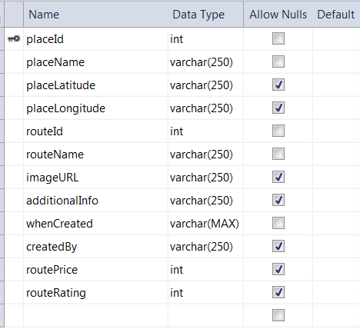

Below is the table with data updated by the app.



1. Mobile User Interface

This app can be accesed both through as a mobile client and desktop client. Twiter Bootstrap has been used to style the pages of the app so their format remains consistent when accessed through mobile.

Below is the home page of the app accessed with opera mobile

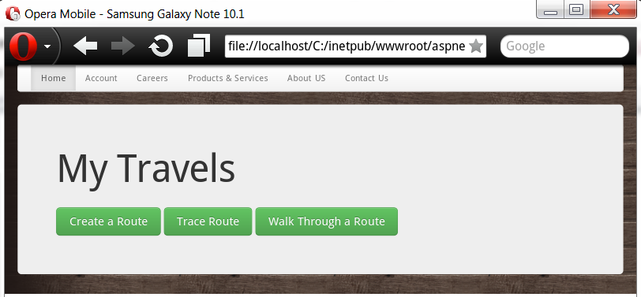

Below is the desktop client version of app’s homepage.

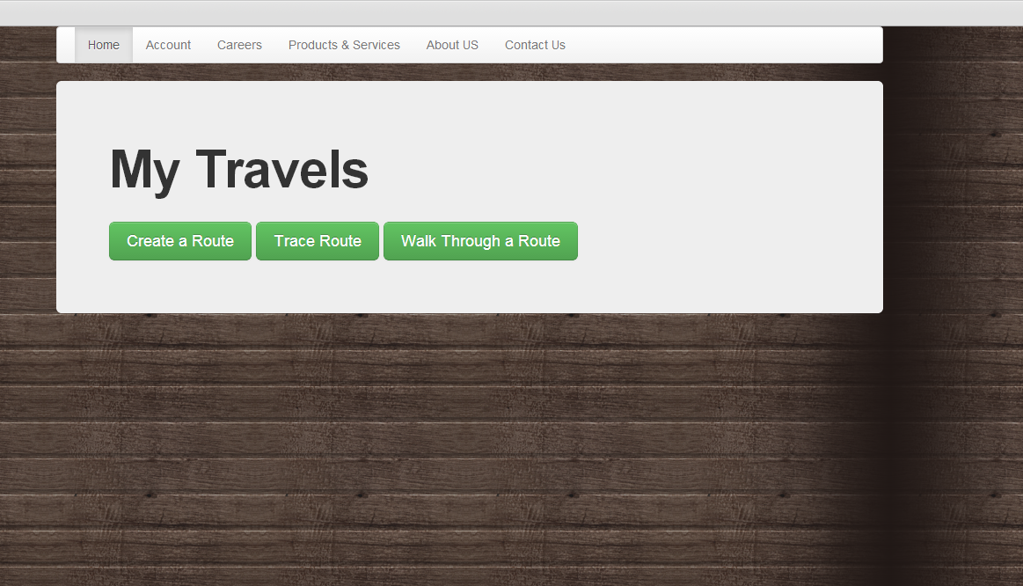

The following features have been implemented:

1. **Create a Route**: This feature allows the user to create a route. On clicking create route, a screen shows up in which the user enters his Route Name, the place that he is visiting, additional information about the place and the image url or path.

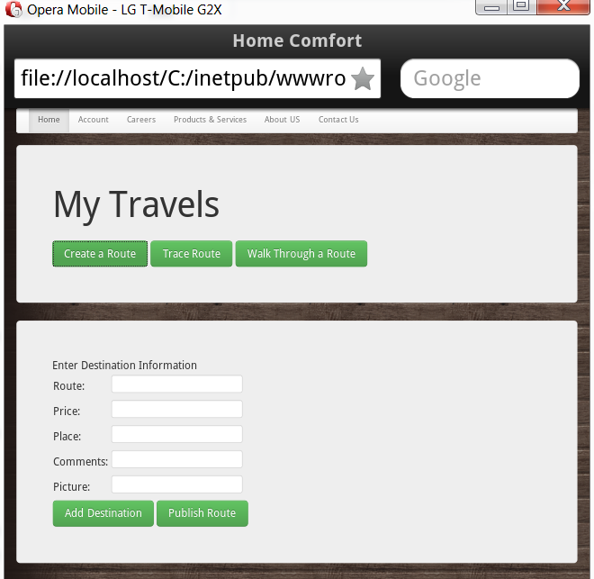

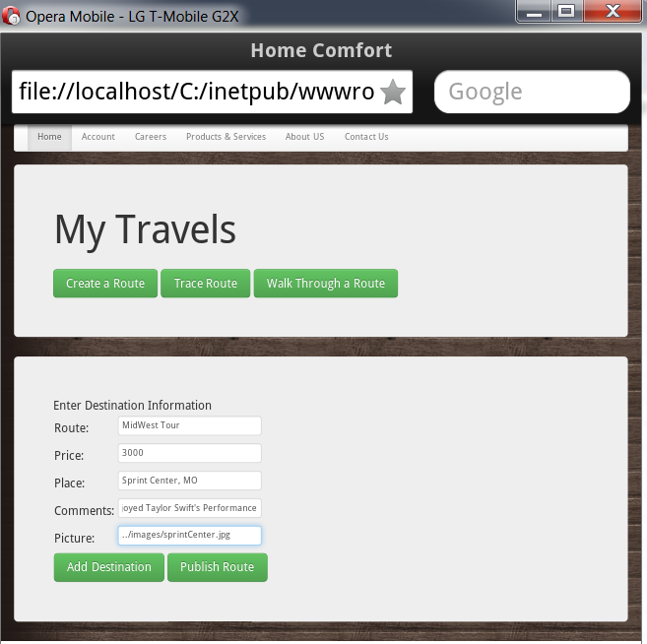

User adds the Route Name, Price and information about the place and clicks on Add Destination. The place name is then used to generate place’s coordinates with google’s geocoder and these coordinates along with place name are passed to Four Square’s search api to validate if the location exists on Four Square.

Users are allowed to enter only those places which are available in Four Square.

If the place exists in Four Square then the place is added to the route and the page gets refreshed for the new place to be entered.

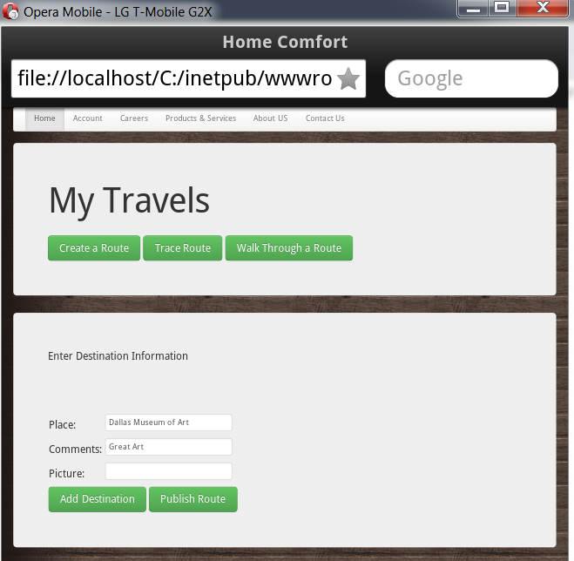

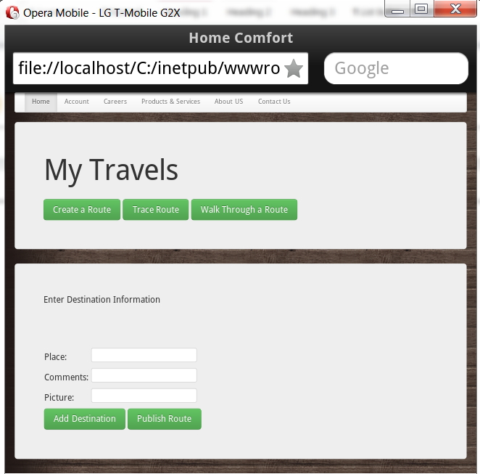

User enters the second place to the route.

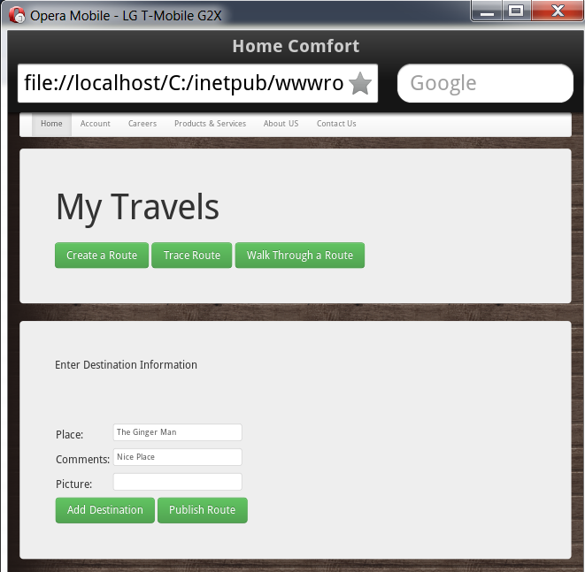

User enters the third place to the route.

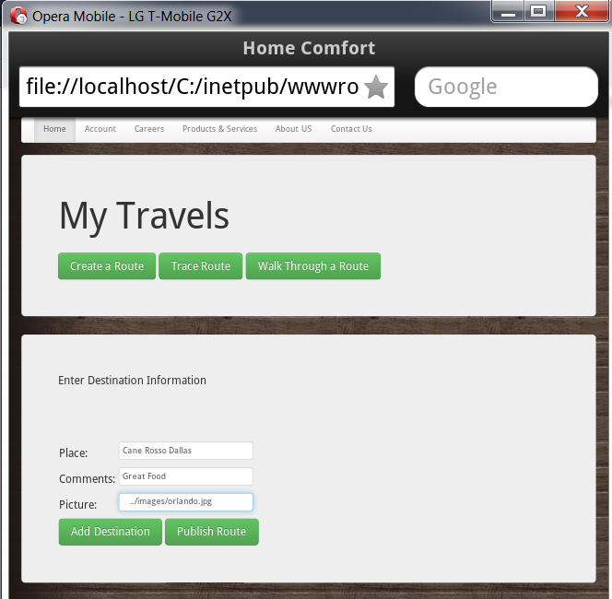

User enters the fourth place to the route.

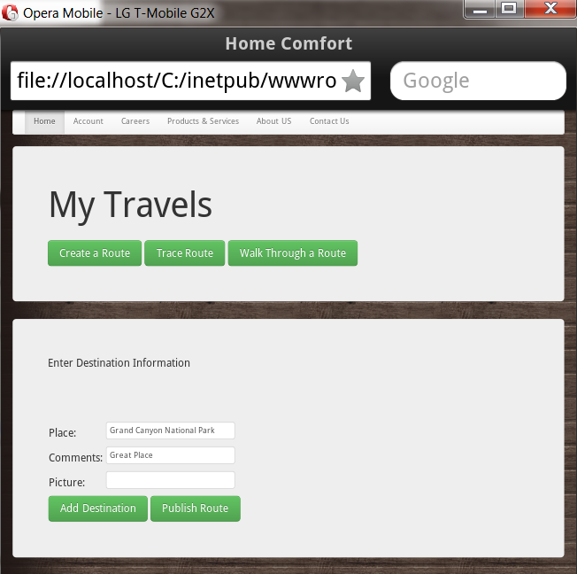

When the user is done visiting all the places then he clicks on Publish route which shows the entire route from source to destination with all the way points visited. He can add a price for the route. On clicking Publish route, the route name, route price along with all the place information are stored in DB.

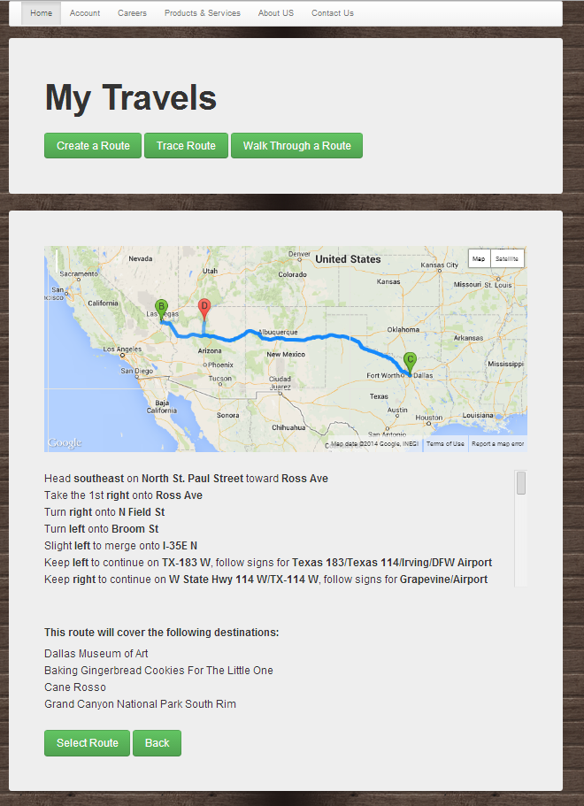

1. **Trace Route**: In order to trace a route, the user first needs to select one.

User can enter his desired source and destination in the text box. On clicking search, all the routes with the specified source and destination along with their route name, rating and price information show up.

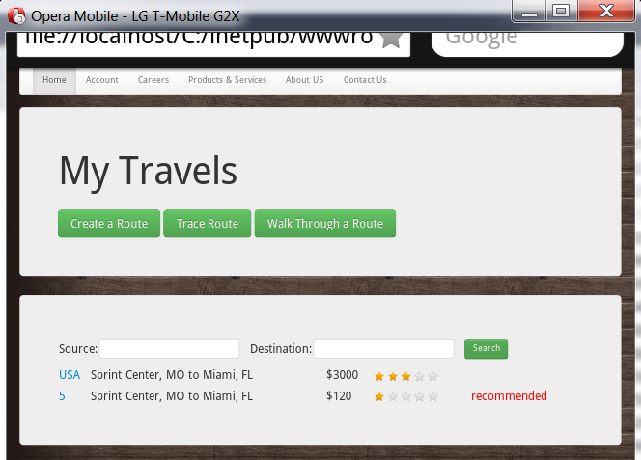

Recommended route

For the source and destination selection this feature also shows the best path which has been computed based on the price of the path and their ratings.

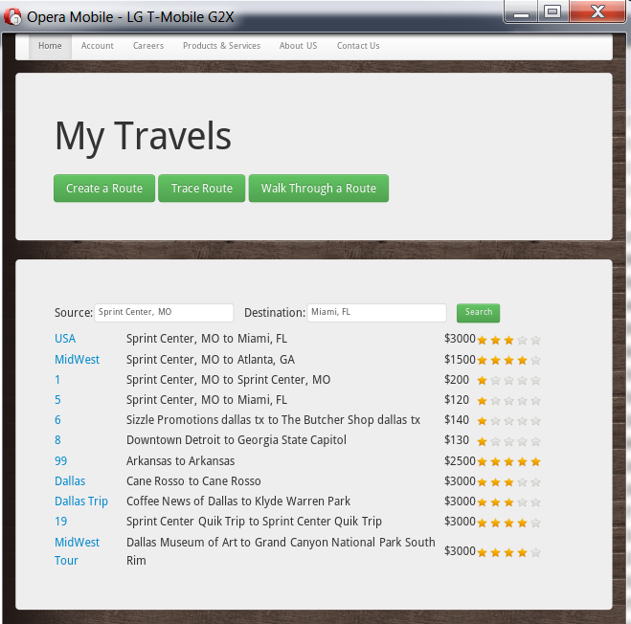

Price

Rating

Alternatively, if the user doesn’t provide any source or destination then all the routes with their respective informations show up.

User can then click on a route name to trace it. On selecting a route, the user can get the route with all its way points on a google map along. He can see directions written. Text to Speech for reading directions has been implemented for navigation to individual places. User can then click on Select Route in order to Walk through it.

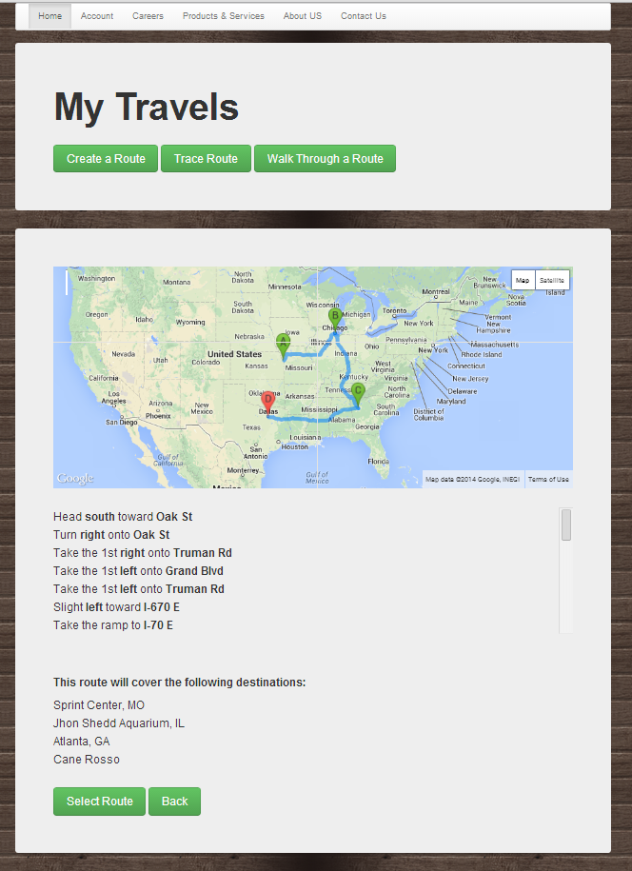

1. **Walk Through a Route:** Once the user has selected a route that he wishes to follow then he can simple click on the route name to see the details.



On clicking walk the route, user sees the information about the first place (destination name, address, contact number etc), this has been populated using the Four Square api for searching a destination. On the same page he can see the pictures posted by the route’s owner and some comments about the place. On the right there is a list of recommended nearby places that the user can visit which have been populated from the Four Square API.

Current location info from Four Square

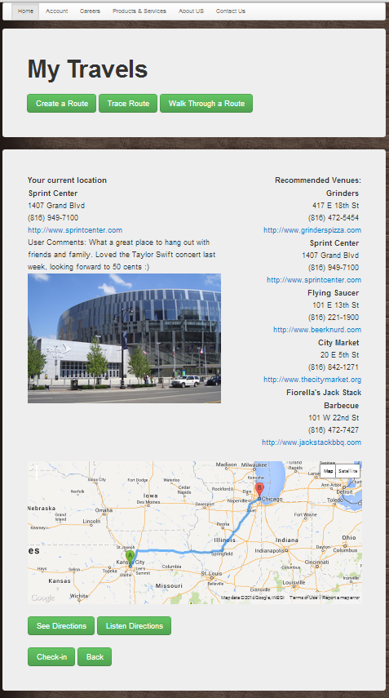

Text to Speech for Directions

Near By recommendation from Four Square

Map from Current to Next Place

At the bottom of the screen the user can see the map for his next destination to be visited from the current destination, the directions are both written and are spoken using text to speech API.

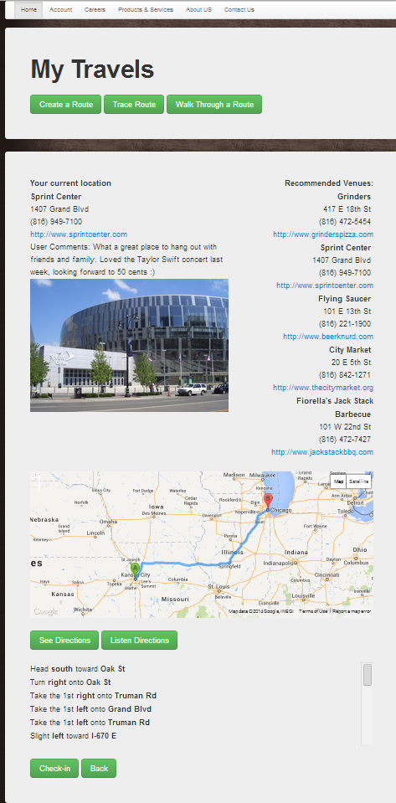

Google Directions Service

User Checks in to the previous place and next shows up along with place information and recommendations

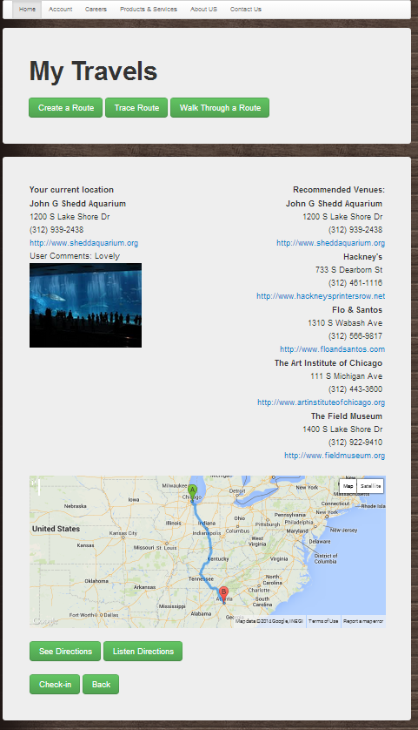

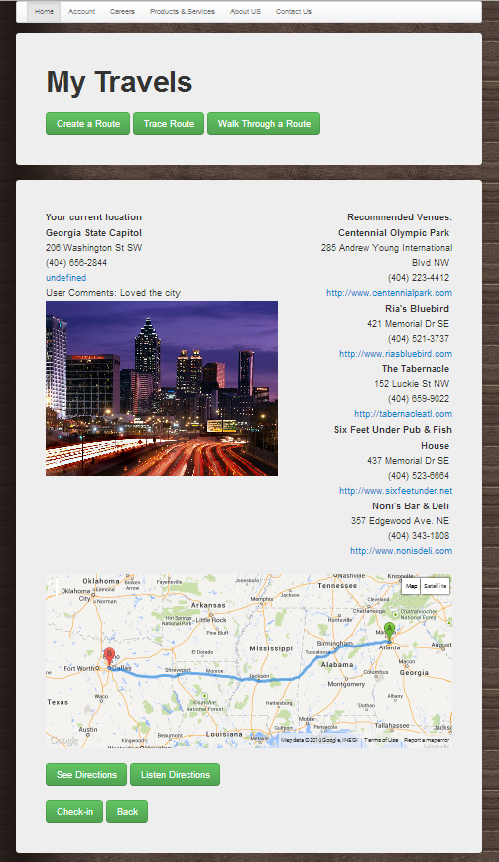

The destination is shown on the map. On clicking Done, the user gets a message with an animation and an option to rate the trip.

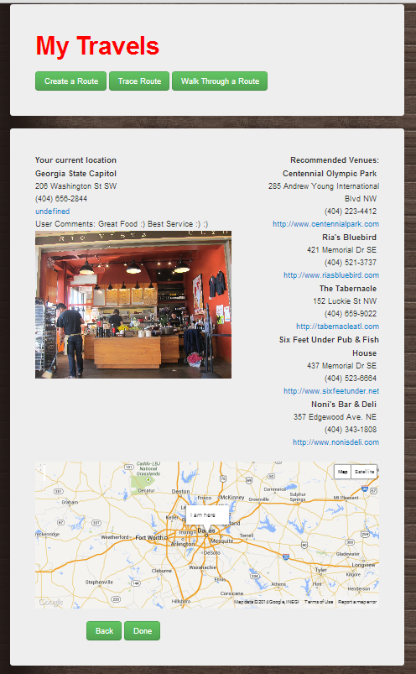

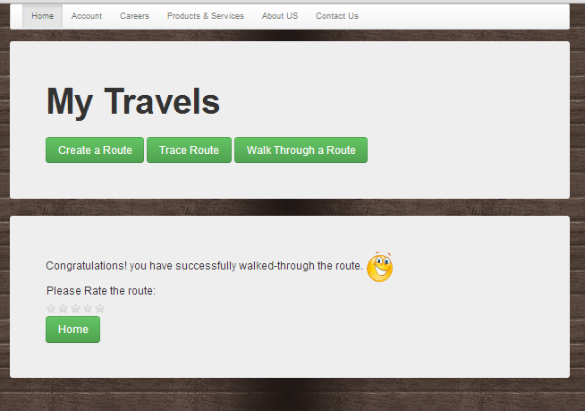

User now rates the trip which is then updated in the DB for this route

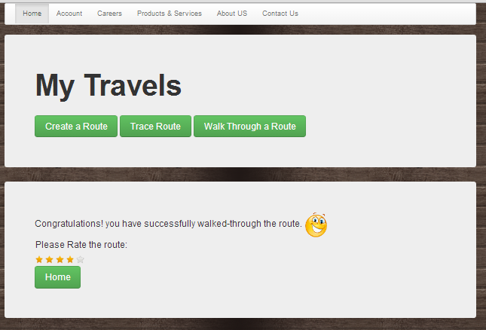

# References

Foursquare website [https://foursquare.com/](https://foursquare.com/%20)

Foursquare API <https://developer.foursquare.com/start>

Google Developer Site [https://developers.google.com/](https://developers.google.com/%20)

Text to Speech http://api.voicerss.org

**GitHub Link: https://github.com/mszzf/Megha-Repository/tree/master/Midterm/exam**